COMSYS 305 Mini-Project Design Report

Team 30

* Game Strategy
  + The game is based on an older game called Flappy Bird which was popular in the past. The game involves a bird that must navigate its way through a 2d pipe obstacle course. The user moves the mouse by clicking with a mouse making the bird jump with every click. By timing the clicks perfectly, the bird will be able to navigate its way through the course with ease. Otherwise, the bird will hit the pipe or the ceiling or the ground and the game will end.
* Design Specification
  + Display
    - The VGA has a resolution of 640 x 480 pixels to display the game. There will be visual elements such as the bird, level and score indicators, pipes, special items such as coins or hearts and a static background.
  + User Interface
    - The user can control the bird using the PS/2 mouse, the DIP switches will allow the user to select between training and single-player mode. Through push-buttons, the user will be able to start the game and resume/pause the game.
  + Game Logic
    - There will be a continuous update on the screen updating the bird’s location on the display which will be based on the mouse left clicks and gravity. The length of the pipes will be randomly generated while being evenly spaced apart, with this, there will be a continuous collision check to detect if the bird has touched the pipe or the ground. If the bird touches a pipe or the ground a life will be lost. The user’s score increases as they pass more pipes. Once it reaches a certain threshold the level will increase and repeat this process until the highest level of three. So, the game will constantly keep track of the birds score, level and remaining lives until none remain.
  + Hardware Integration
    - Using VHDL, the code will interface with the DE0-CV board for multiple inputs and outputs. Control signals or input examples will include the PS/2 mouse to control the bird and the DIP switches to select between the two game modes. Outputs will include generating the RGB values for the VGA display to render the game and the main elements of the game such as score, levels and lives of the user.
* Block Diagram

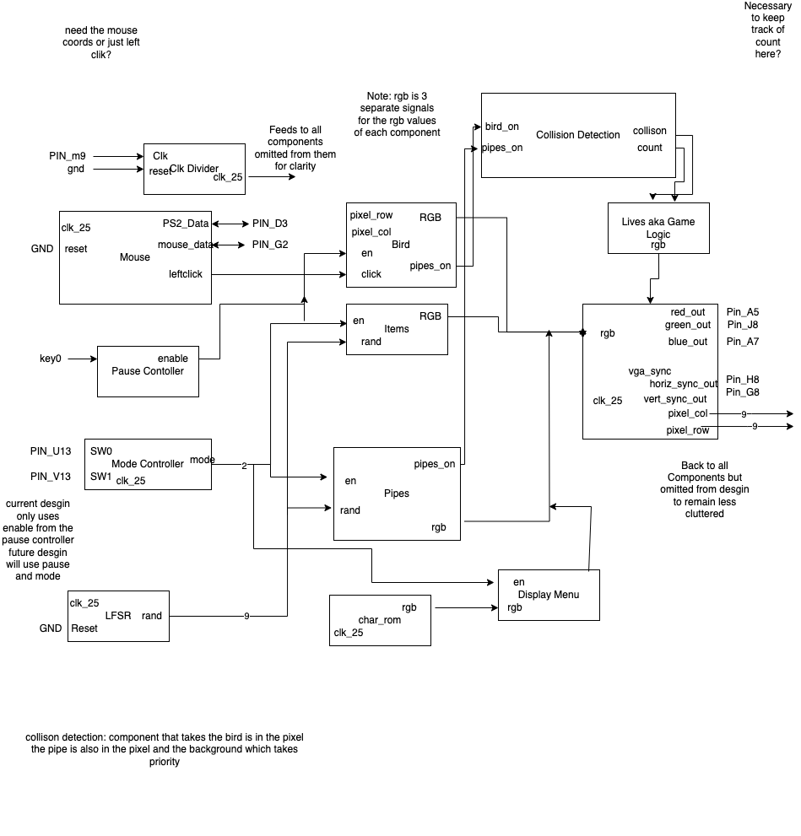

- High Level State Machine

